ARM Template

AzureDeploy.json:

Json—Structure

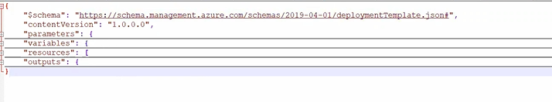

Parameters—Static data not modified data

Variable ---Dynamic data its modified data

Like storage account

Like function

Resource –actually deployment data

Resource will start square bracket will defined array.

Azuredepoy.paramater.json

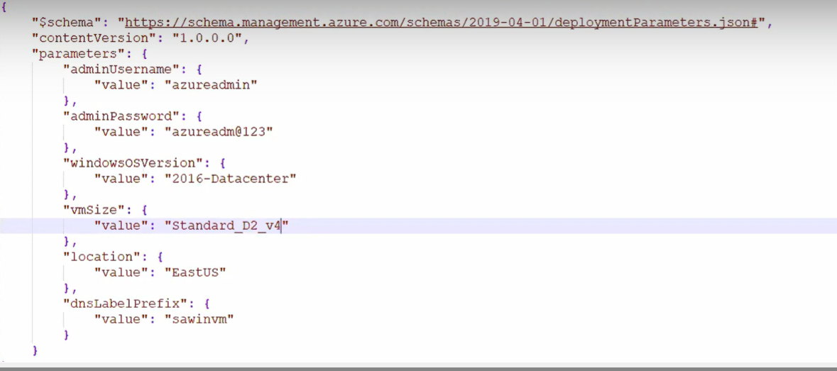

Functions:

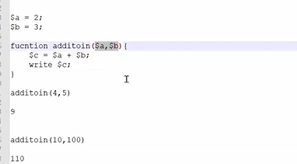

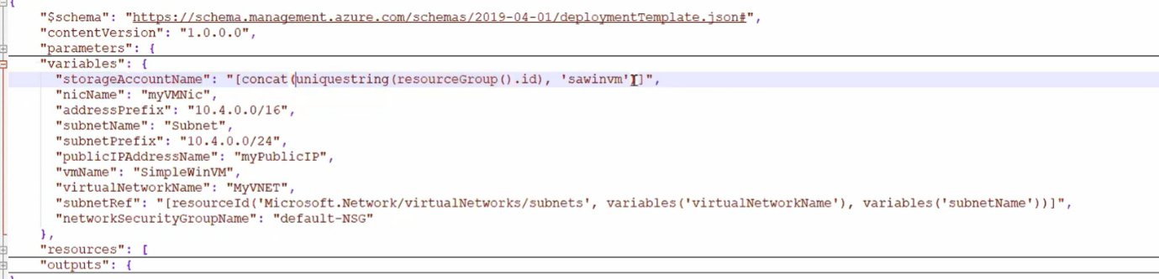

Function link.

<https://learn.microsoft.com/en-us/azure/azure-resource-manager/templates/template-functions>

We will do three way

Template

PowerShell

Azure module need to install

Get-module

gcm“module”

We need connect Subscription

Connect-azaccount

Once connect will see subscription

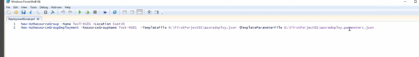

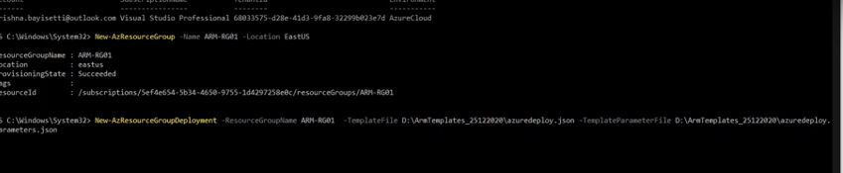

<https://github.com/Azure/AzureStack-QuickStart-Templates/blob/master/101-simple-linux-vm-custom-managed-disk/azuredeploy.json>

ARM template with Azure Pipeline

Classic pipeline:

Task: Arm template deployment

Azure with Azure Devops

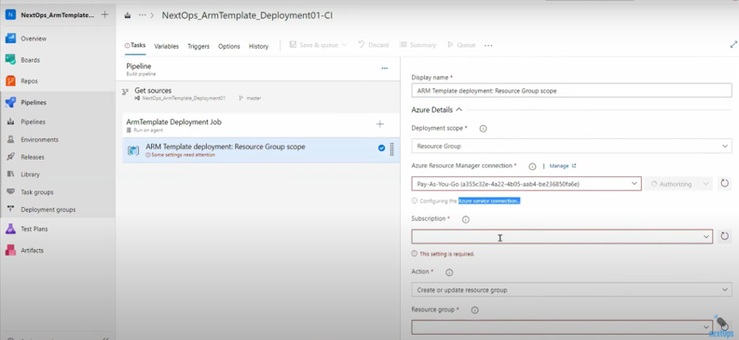

Deployment

Multiple resource creating In azure using--- Array

Three resources --First resource using Dependson

In case not input will take default value

One resource group created—again will run / multiple run

Yes –Override chestudi

Logic Apps: ARM Template deployment

Azure App service Deploy

Azure key vault

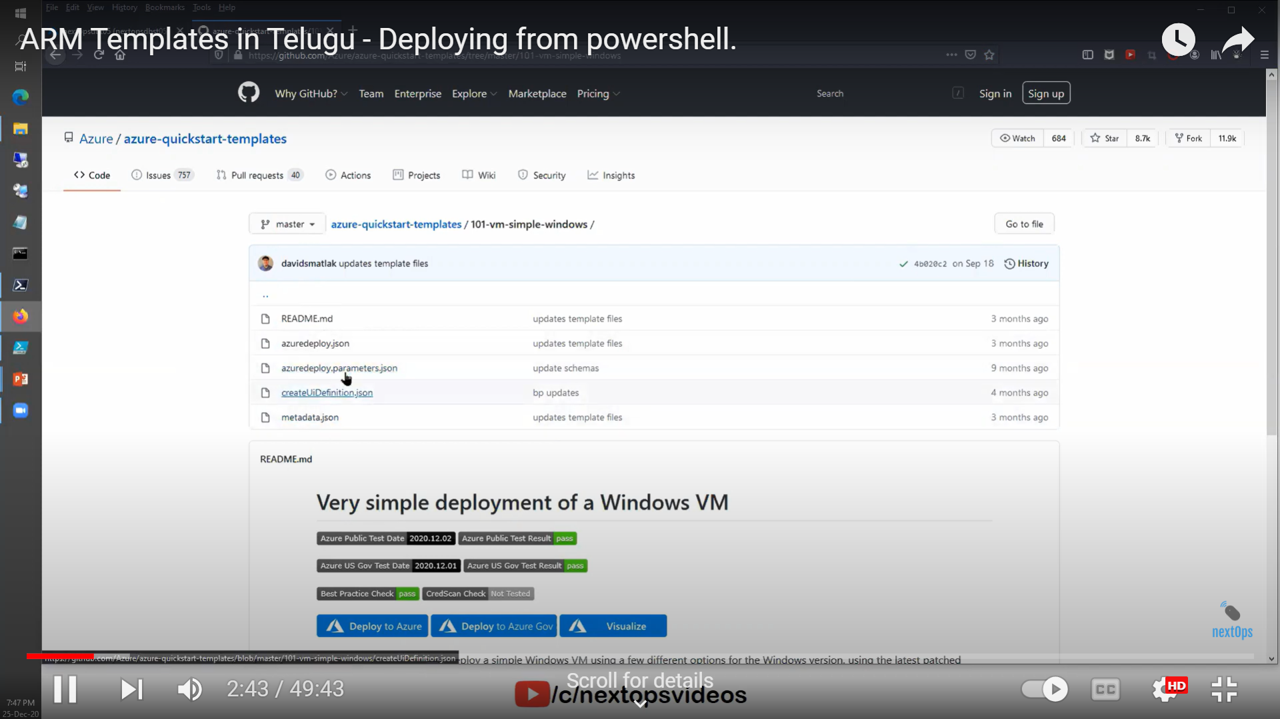

Json file: